ASE CS 5551 Lab Assignment 2

Student Name: Patel Marmikkumar

Class ID: 43

Application Name: DistanceFinder

API Used: Google Maps Distance Matrix API

This application uses Google Distance Matrix API to find distance and duration to travel between to enter point.

Screenshots:

1. Login Page

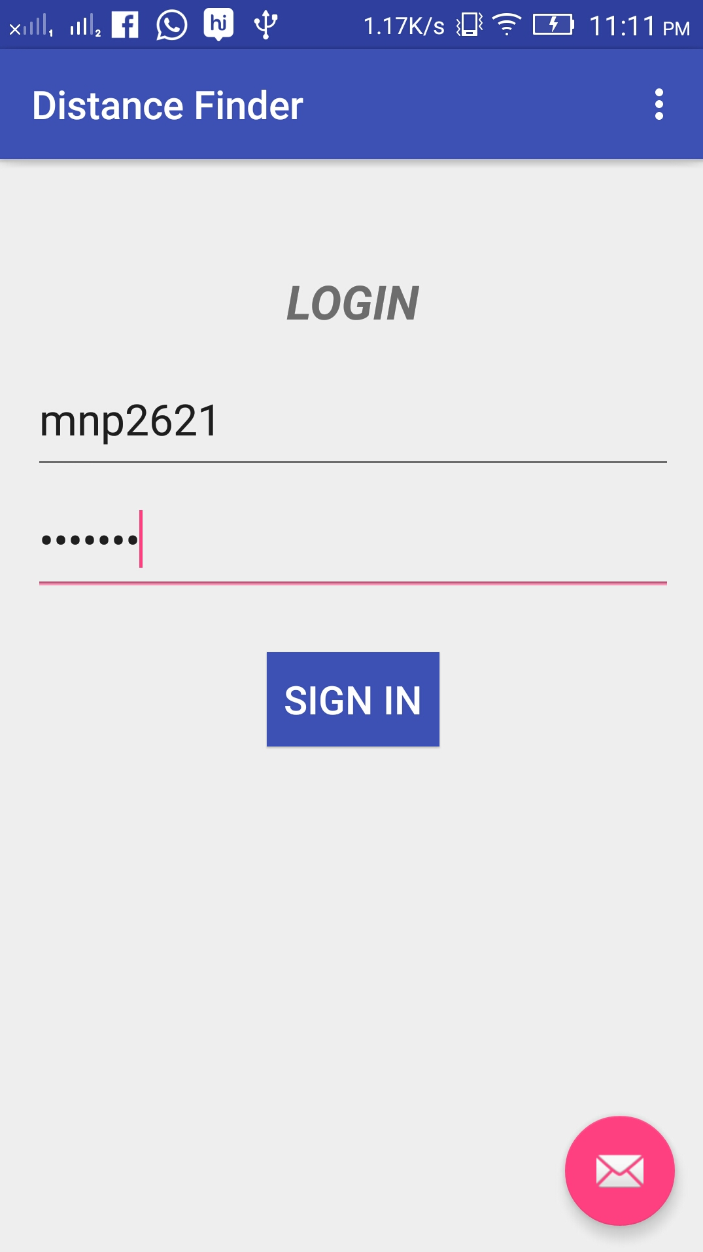

1. Distance Finder API ( before input )

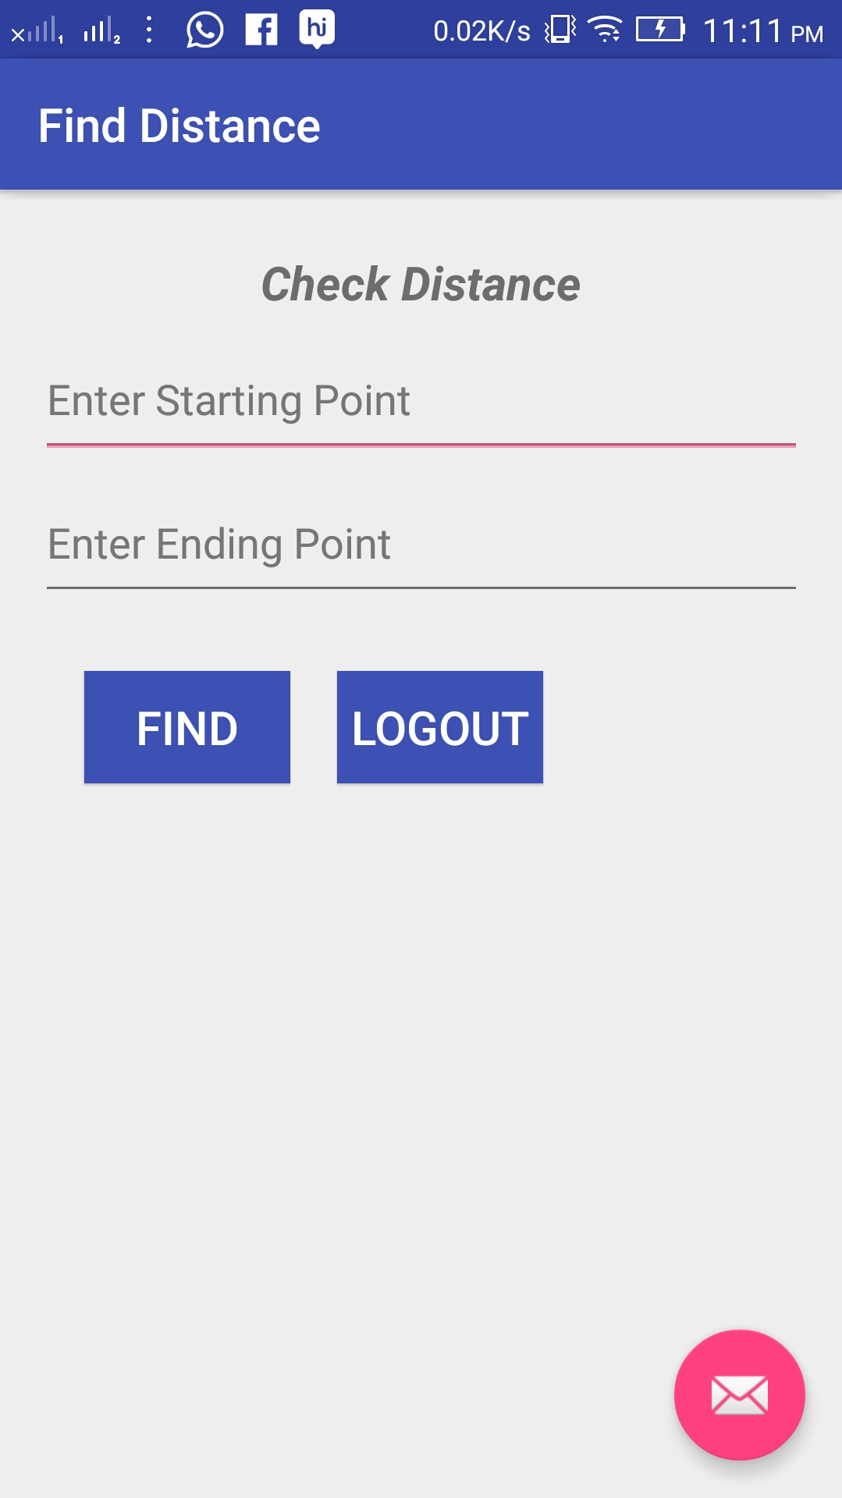

1. Distance Finder Page ( after input and getting output )

